REPUTATION & CHARACTER

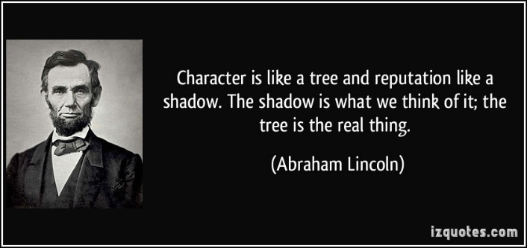The circumstances amid which you live determines your reputation;  
the truth you believe determines your character. Reputation is what you are supposed to be;  
character is what you are. Reputation is the photograph;  
character is the face. Reputation comes over one from without;  
character grows up from within Reputation is what you have when you come to a new community;  
character is what you have when you go away. Your reputation is learned in an hour;  
your character does not come to light for a year. Reputation is made in a moment;   
character is built in a lifetime. Reputation grows like a mushroom;  
character grows like the oak. A single newspaper report gives you your reputation;  
a life of toil gives you your character. Reputation makes you rich or makes you poor;  
character makes you happy or makes you miserable. Reputation is what men say about you on your tombstone;  
character is what angels say about you before the throne of God.

William Hershey Davis

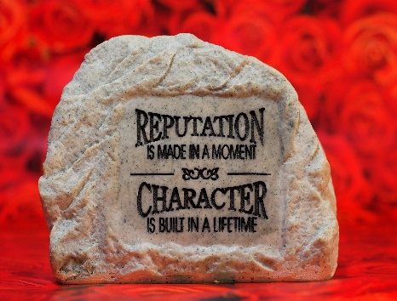“Your character is what God knows you to be. Your reputation is what men think you are.” The real measure of a man’s character is what he would do if he knew he would never be found out.”

# DISTRIBUTED BY YOUR FRIENDS AT





**“Serving God’s Servants”**

10817 E. 16th Avenue * Spokane Valley, WA 99206

509.995.6777 * ghippe@integrity.com

www.eaglesummitministry.org