[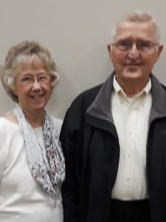](http://eaglesummitministry.org/wp-content/uploads/2014/05/Geis-2.jpg)